Traffic Signal Optimization

Team members:
2520030587-Sai Spoorthi
2520030586-Hamsika
2520030591-Sudeshna

Abstract
This project proposes a Smart Traffic Signal Optimization System using Rule-Based AI, Greedy Search, and Constraint Satisfaction techniques. The system analyzes traffic conditions based on vehicle count and waiting time. A Priority Score is calculated and used to determine optimal signal timing. The system supports both predefined traffic scenarios and custom traffic inputs. The solution provides explainable decision-making and efficient traffic management while remaining simple and cost-effective.

Problem Statement
Conventional traffic signal systems operate with fixed timing cycles regardless of traffic conditions. This leads to unnecessary waiting time, congestion, fuel wastage, pollution, and delayed emergency vehicle movement. Therefore, a smart traffic management system is required that can dynamically adjust signal timings using intelligent rule-based logic.

Solution
The proposed solution is a Smart Traffic Signal Optimization System developed using Python. The system allows users to select predefined traffic scenarios or enter custom traffic parameters such as vehicle count and waiting time. A Priority Score is calculated and a Greedy Search strategy selects the optimal signal duration. Constraint Satisfaction techniques ensure signal timing remains within operational limits. The system provides explainable reasoning for every decision.

Plan of Action
Module | Description
Traffic State Representation Module | Stores traffic conditions using Python dictionaries and predefined states.
Greedy Search & Signal Optimization Module | Calculates Priority Score and selects optimal signal duration using Greedy Search.
Constraint Satisfaction & Decision Agent Module | Validates timing constraints and generates explainable signal decisions.

PEAS Model
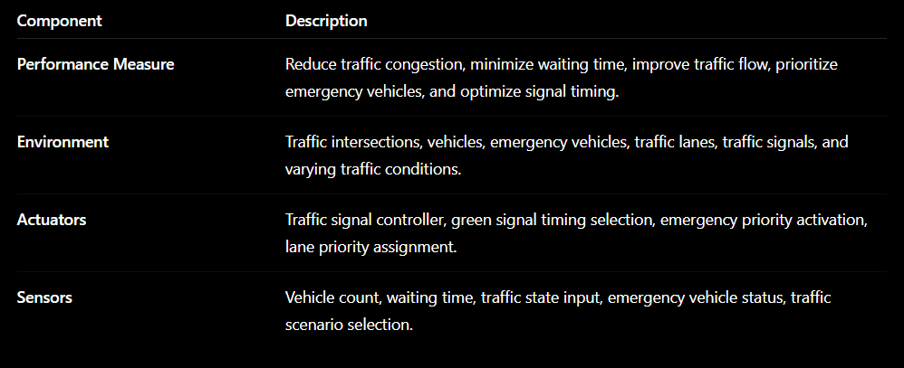
Algorithm
Step 1: User selects a predefined traffic scenario or enters custom traffic data.
Step 2: System retrieves vehicle count and waiting time.
Step 3: Calculate Priority Score = (Vehicle Count × 2) + Waiting Time.
Step 4: Apply Greedy Search to determine signal duration.
Step 5: Check constraints (Signal Time ≤ 60 seconds).
Step 6: Display AI reasoning, decision, and state transition.

CO’s Attainments

CO1: State representation using Python dictionaries and traffic states.
CO2: Greedy Search selects optimal signal timing.
CO3: Constraint Satisfaction validates signal timing limits.
CO4: Intelligent decision-making agent selects actions.
CO5: no probabilistic reasoning.
CO6: Integrated reasoning pipeline with explainable outputs.

CODE
# ==========================================
# SMART TRAFFIC SIGNAL OPTIMIZATION SYSTEM
# ==========================================
TRAFFIC_DATA = {
"Low Traffic": {
"vehicles": 12,
"waiting": 8
},
"Medium Traffic": {
"vehicles": 35,
"waiting": 18
},
"High Traffic": {
"vehicles": 57,
"waiting": 31
},
"Emergency Vehicle": {
"vehicles": 20,
"waiting": 5
}
}
# ==========================================
# CO2 : GREEDY SEARCH
# ==========================================
def greedy_signal_selection(priority_score):
if priority_score > 120:
return 60
elif priority_score > 60:
return 40
else:
return 20
# ==========================================
# CO3 : CONSTRAINT SATISFACTION
# ==========================================
def check_constraints(signal_time):
if signal_time <= 60:
return "✓ Signal Time Constraint Satisfied"
return "✗ Signal Time Constraint Violated"

# ==========================================
# CO4 : DECISION MAKING AGENT
# ==========================================

def traffic_agent(state):

data = TRAFFIC_DATA[state]

vehicles = data["vehicles"]
waiting = data["waiting"]

priority_score = (vehicles * 2) + waiting

if state == "Emergency Vehicle":

signal_time = 60
decision = "Emergency Override Activated"

else:

signal_time = greedy_signal_selection(priority_score)

if signal_time == 60:
decision = "Heavy Congestion Detected"

elif signal_time == 40:
decision = "Moderate Traffic Flow"

else:
decision = "Normal Traffic Flow"

print("\n====================================")
print("SMART TRAFFIC SIGNAL OPTIMIZATION")
print("====================================")

print("Current State :", state)

print("\nTraffic Data")
print("----------------------------")
print("Vehicle Count :", vehicles)
print("Waiting Time :", waiting)

print("\nAI Reasoning")
print("----------------------------")
print("Priority Score =", priority_score)

print("\nDecision")
print("----------------------------")
print(decision)

print("\nSignal Timing")
print("----------------------------")
print(signal_time, "seconds")

print("\nConstraint Check")
print("----------------------------")
print(check_constraints(signal_time))

print("\nState Transition")
print("----------------------------")

if state == "Low Traffic":
print("Low Traffic -> Medium Traffic")

elif state == "Medium Traffic":
print("Medium Traffic -> High Traffic")

elif state == "High Traffic":
print("High Traffic -> Emergency Vehicle")

else:
print("Emergency Vehicle -> Normal Traffic")

# ==========================================
# CUSTOM ANALYSIS
# ==========================================

def custom_traffic_analysis():

print("\nCUSTOM TRAFFIC ANALYSIS")

vehicles = int(input("Enter Vehicle Count : "))
waiting = int(input("Enter Waiting Time : "))

if vehicles > 50:

state = "High Traffic"

elif vehicles > 25:

state = "Medium Traffic"

else:

state = "Low Traffic"

priority_score = (vehicles * 2) + waiting

signal_time = greedy_signal_selection(priority_score)

if signal_time == 60:
decision = "Heavy Congestion Detected"

elif signal_time == 40:
decision = "Moderate Traffic Flow"

else:
decision = "Normal Traffic Flow"

print("\n====================================")
print("CUSTOM TRAFFIC RESULT")
print("====================================")

print("Traffic Type :", state)

print("\nTraffic Data")
print("----------------------------")
print("Vehicle Count :", vehicles)
print("Waiting Time :", waiting)

print("\nAI Reasoning")
print("----------------------------")
print("Priority Score =", priority_score)

print("\nDecision")
print("----------------------------")
print(decision)

print("\nSignal Timing")
print("----------------------------")
print(signal_time, "seconds")

print("\nConstraint Check")
print("----------------------------")
print(check_constraints(signal_time))

# ==========================================
# MAIN MENU
# ==========================================

while True:

print("\n====================================")
print("SMART TRAFFIC SIGNAL OPTIMIZATION")
print("====================================")
print("1. Low Traffic")
print("2. Medium Traffic")
print("3. High Traffic")
print("4. Emergency Vehicle")
print("5. Custom Traffic Analysis")
print("6. Exit")
print("====================================")

choice = input("Enter Choice : ")

if choice == "1":

traffic_agent("Low Traffic")

elif choice == "2":

traffic_agent("Medium Traffic")

elif choice == "3":

traffic_agent("High Traffic")

elif choice == "4":

traffic_agent("Emergency Vehicle")
elif choice == "5":
custom_traffic_analysis()
elif choice == "6":
print("\nProgram Ended Successfully.")
break

else:
print("\nInvalid Choice. Please Try Again.")

OUTPUT:
For High Traffic
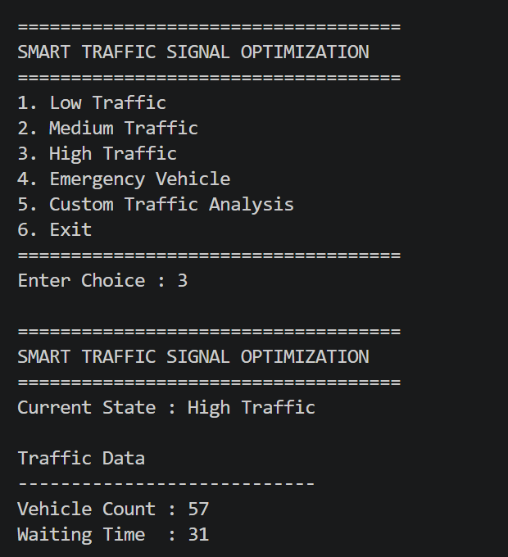
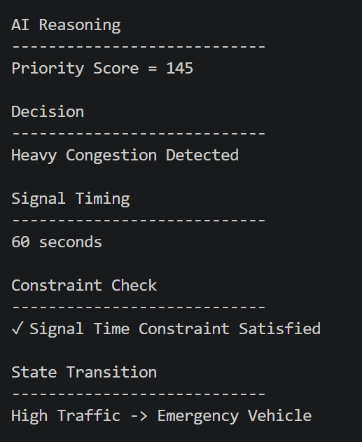

For Custom Traffic Inputs
